Code Review 1: Netlogo Eco Simulation

Daniel Mcdonough, 4/2

# Introduction:

This code review was done with code from Student Maddy Longo. Maddy is writing a simulation for invasive species in Netlogo. The following review discusses the behavior of her flower agents.

# Code Review:

Figure 1 shows the functionality of the flower growth. It is to be noted that her simulation involves two different flowers with similar properties. Meant to ease her coding process he made a parent class flowers and enabled their specific fields through global variables. This makes most of her code result in if statements to determine the variety of flowers. The behavior of the bees is not coded in yet however they are supposed to keep track of their favorite flower within their first 5 flower encounters based on pollen obtained.

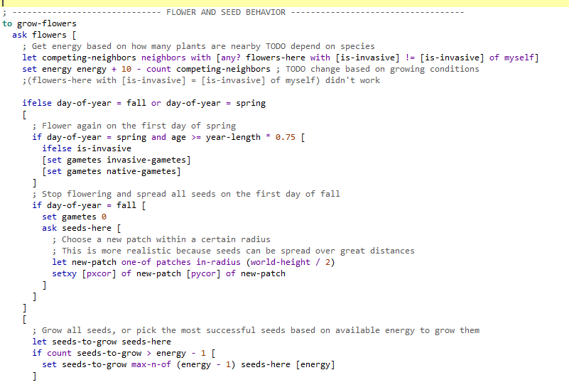

Figure : Code in the FLOWER AND SEED Behavior.

# Discussion and suggestions:

Upon review of this code, I would suggest making a to-return function that determines the type of flower to further ease the differentiation of flowers and make smaller code. It would also be useful to add a cap on the bee population so they don’t explode and crash the program. Also when implementing the bee’s memory I would recommend including the “extensions [array]” to enable arrays and make it much easier to keep track of the bee’s flower history.